Yolanda Brown

Module 2.3-Data Models

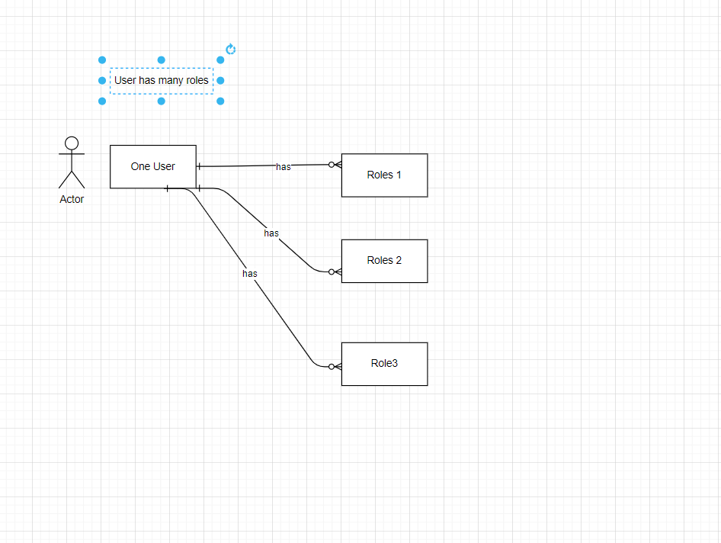

User has one birthday

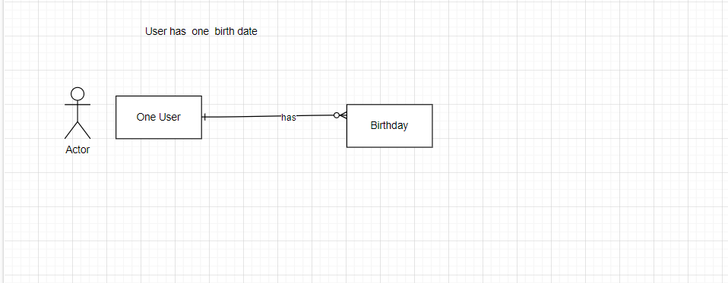

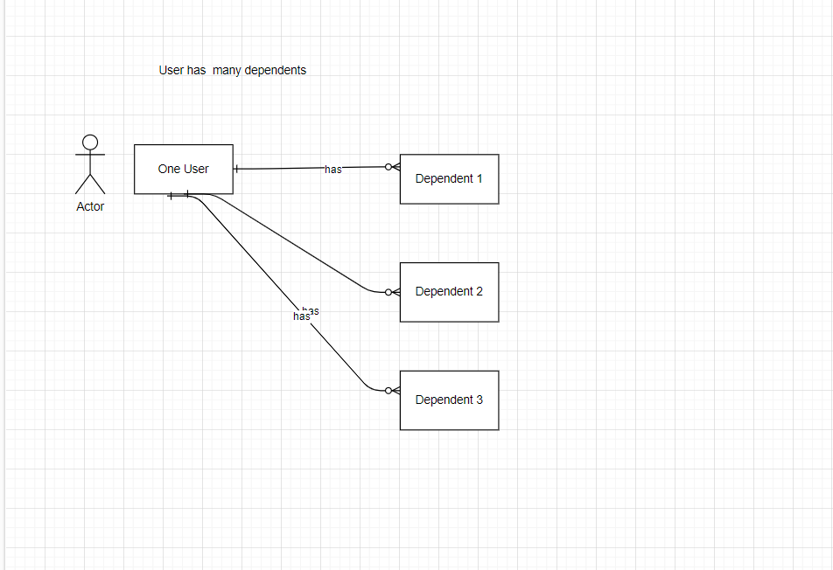

No sql

User 1:{

{

Role1: title

Role: First Name

Role: Last Name

}

{

Role2: title

Role: First Name

Role: Last Name

}

}

{

Role3: title

Role: First Name

Role: Last Name

}